Pizza Sales Information

Dataset Overview
- The dataset consists of 4 related tables: orders, order details, pizzas, and pizza types, which together provide complete information about pizza sales transactions. It includes details such as order date and time, pizza name, category, size, quantity, and price. The dataset is useful for analyzing stability in price, sales trends, revenue performance, and product popularity, helping businesses make data-driven decisions.
- The project demonstrates how SQL can be applied in real-world business scenarios to know about their customers and the demand of the products in the market.
Business Insights / Important Points
Q1. Retrieve the total number of orders placed?
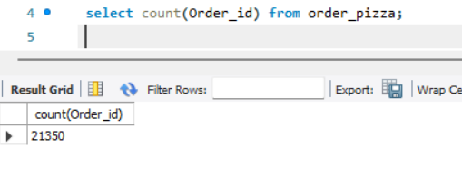
Observation:
- The business received 21,350 total orders, showing strong customer demand and steady sales activity.
Q2. Calculate the total revenue generated from pizza sales.

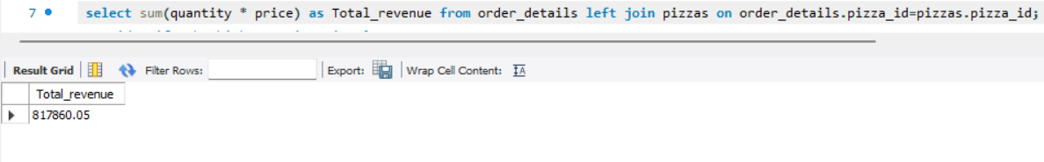
Observation:
- The pizza business generated approximately $817,860 in total revenue, indicating healthy business performance.
Q3. Identify the highest-priced pizza?

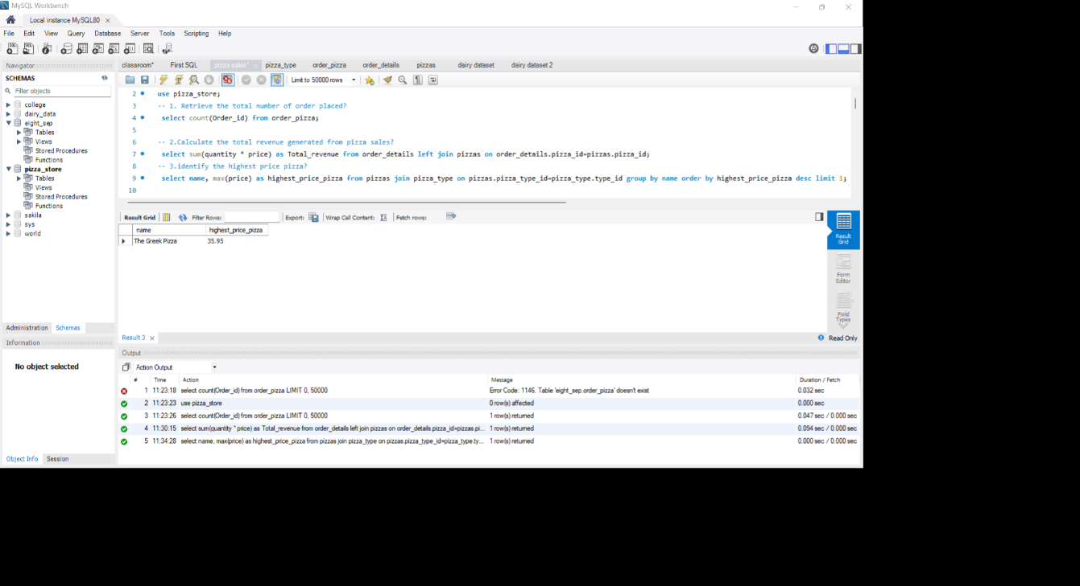
Observation:
- The Greek Pizza has the highest price among all the others pizzas, so they can you premiun offers to lower the price.
Q4. Identify the most common pizza size ordered?
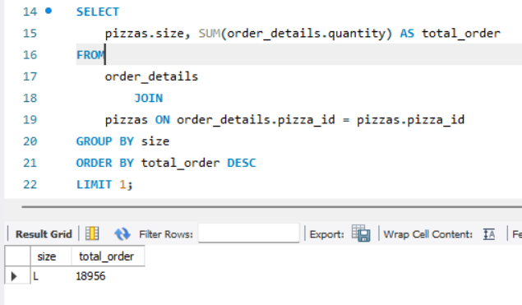
Observation:
- Large (L) size pizzas were ordered the most, suggesting customers prefer larger portion sizes
Because the price of large size pizza is affordable for the customers.

Q5. List the top 5 most ordered pizza types along with their quantities?
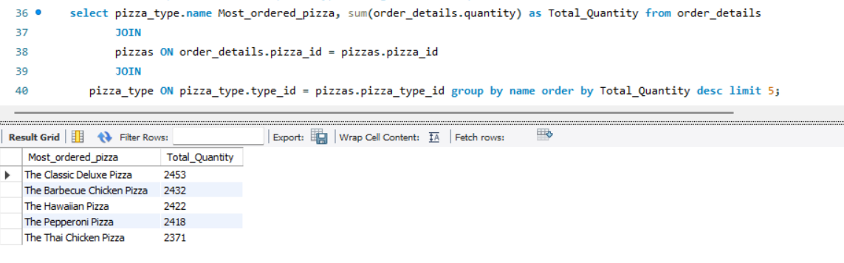
Observation:
- The analysis identifies the total quantity ordered of each pizza types, helping businesses understand which products contribute the most to overall.
- These top 5 pizzas are the most popular and should be prioritized in menu promotions.

Q6. Join the necessary tables to find the total quantity of each pizza category ordered?
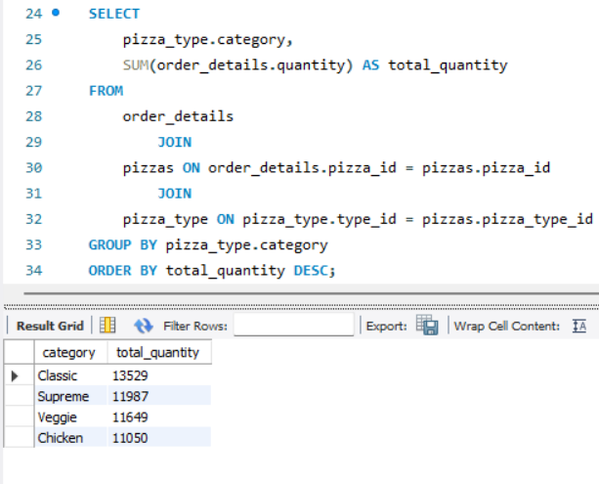
Observation:
- This question help the business to understand which pizza type category plays a major role in quantity ordered by the customers.
- The most of the customers prefer to ordered the classic pizza category as compared to others.
Q7. Determine the distribution of orders by hour of the day?
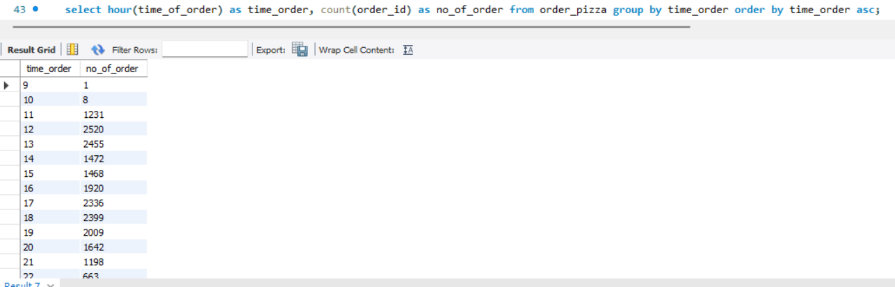
Observation:
- Order volume increases significantly during lunch and evening hours, showing customer demand peaks at meal times.
- There is less demand for the pizza at the opening and closing hours of the business.
Q8. Join relevant tables to find the category-wise distribution of pizzas?
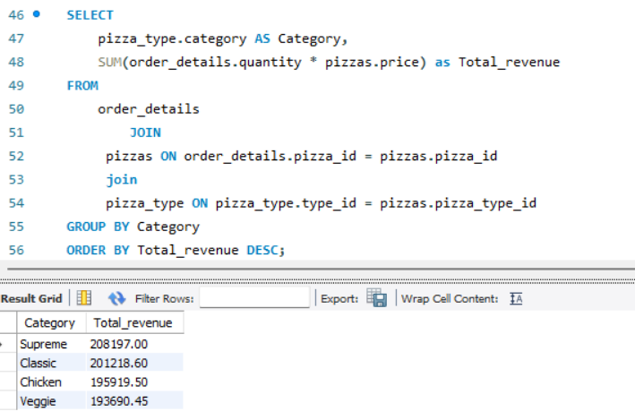
Observation:
- Customers tend to prefer popular classic and chicken-based pizzas, indicating flavour preference trends.
- The business can try some new pizza category for their customers to increase their revenue.

Q9. Group the orders by date and calculate the top 3 days with highest total orders?
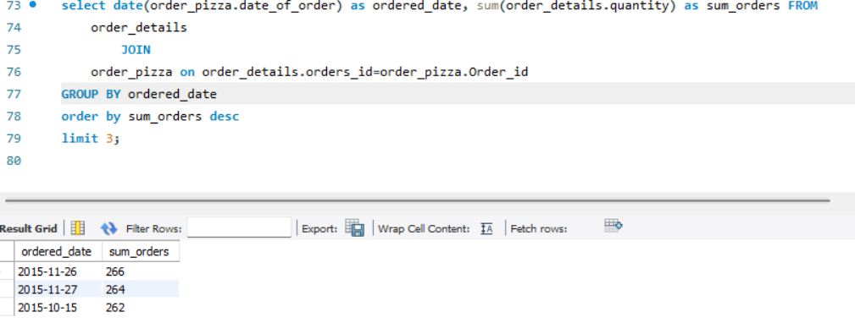
Observation:
- These top 3 days has the highest sum of orders as compared to others days.
- Customer are likely to buy more pizzas in October and November months.
Q10. Determine the top 3 most ordered pizza types based on revenue?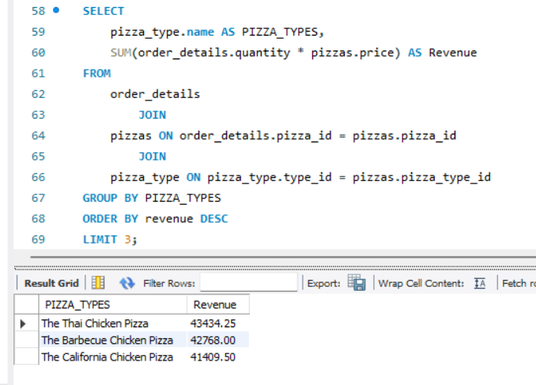
Observation:
- These top 3 pizza types are the revenue leaders of the business, they contribute significantly to profit.
Tools & Features used
- SQL (Structured Query Language)
Used to query and analyze the pizza sales database for extracting meaningful business insights.
- Aggregate Functions
Functions like SUM(), COUNT(), AVG() were used to calculate total revenue, total orders, and average sales.

- GROUP BY Clause
Used to group data by category, pizza type, date, and hour for analysis.

- JOIN Operations
Used to combine data from multiple tables (orders, order_details, pizzas, pizza_types) for complete analysis.

- Microsoft Word Documentation
Used to present SQL queries, screenshots of outputs, and project explanations in a structured report format.

Conclusion
The pizza sales analysis shows that the business performs strongly with high order volume and strong revenue generation. Customer demand is highest for Classic pizzas and Large-sized orders, while a few premium pizzas contribute significantly to revenue. By focusing on popular products, optimizing low-performing items, improving inventory planning, and targeting peak-hour sales, the business can improve profitability and customer satisfaction.

